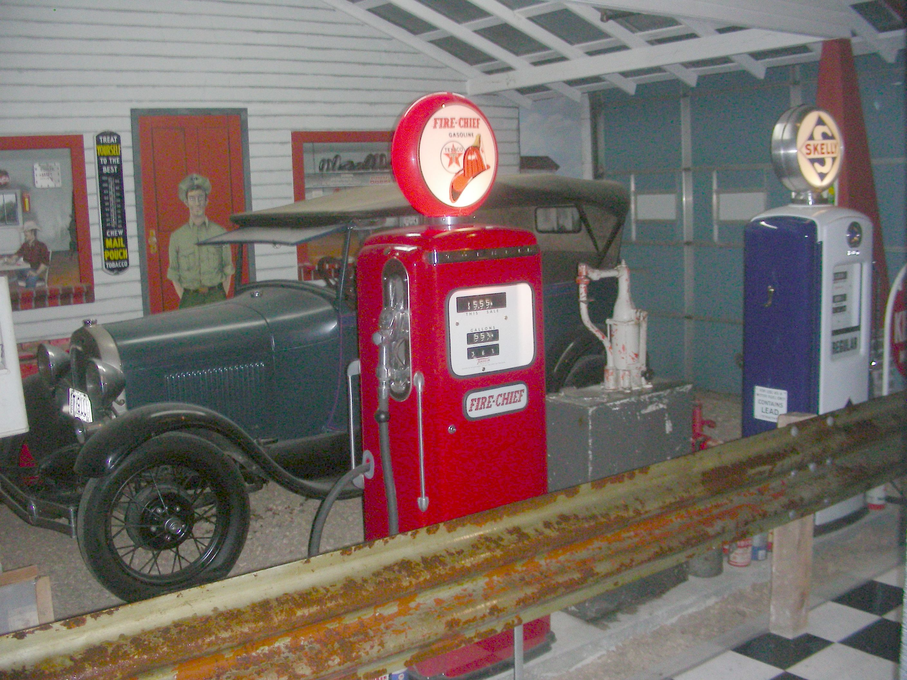

Gas Prices on RT 66 Trip 2022

10/23 Edwardsville, IL $3.49
10/24 Lebonon, MO $3.39
10/25 Oklahoma City, OK $3.29
10/26 Elk City, OK $3.49
10/27 Santa Rosa, NM $3.59
10/28 Abl, NM $3.29
10/29 Flagstaff, AZ $4.29
10/31 Needles, CA $6.29
10/31 Twentyning Palms, Ca $5.29
11/02 San Padro, CA $5.69
11/09 Kingsman, AZ $5.09
11/09 Galloup, NM $3.49
11/10 Melrose, NM $3.54
11/11 Shamrock, TX $3.29
11/12 Henretta, OK $3.15
11/12 Memphis, TN $3.25
11/14 Herin, IL $3.75

